On May 4, 2017 Round table "Ecology and Art" was held in the Central Manege exhibition hall. The discusion was organized by the Moscow City Duma and the Academy of Watercolors and Fine Arts of Sergey Andriaka. The round table was attended by the chairman of the Commission on Environmental Policy of the Moscow City Duma Z.M. Zotova, rector of the Academy of Watercolors and Fine Arts, full member of the Academy of Arts of the Russian Federation, People's Artist of Russia S.N. Andriaka, head of the project "In the footsteps of the Red Book" N.I. Nikolaeva and others.

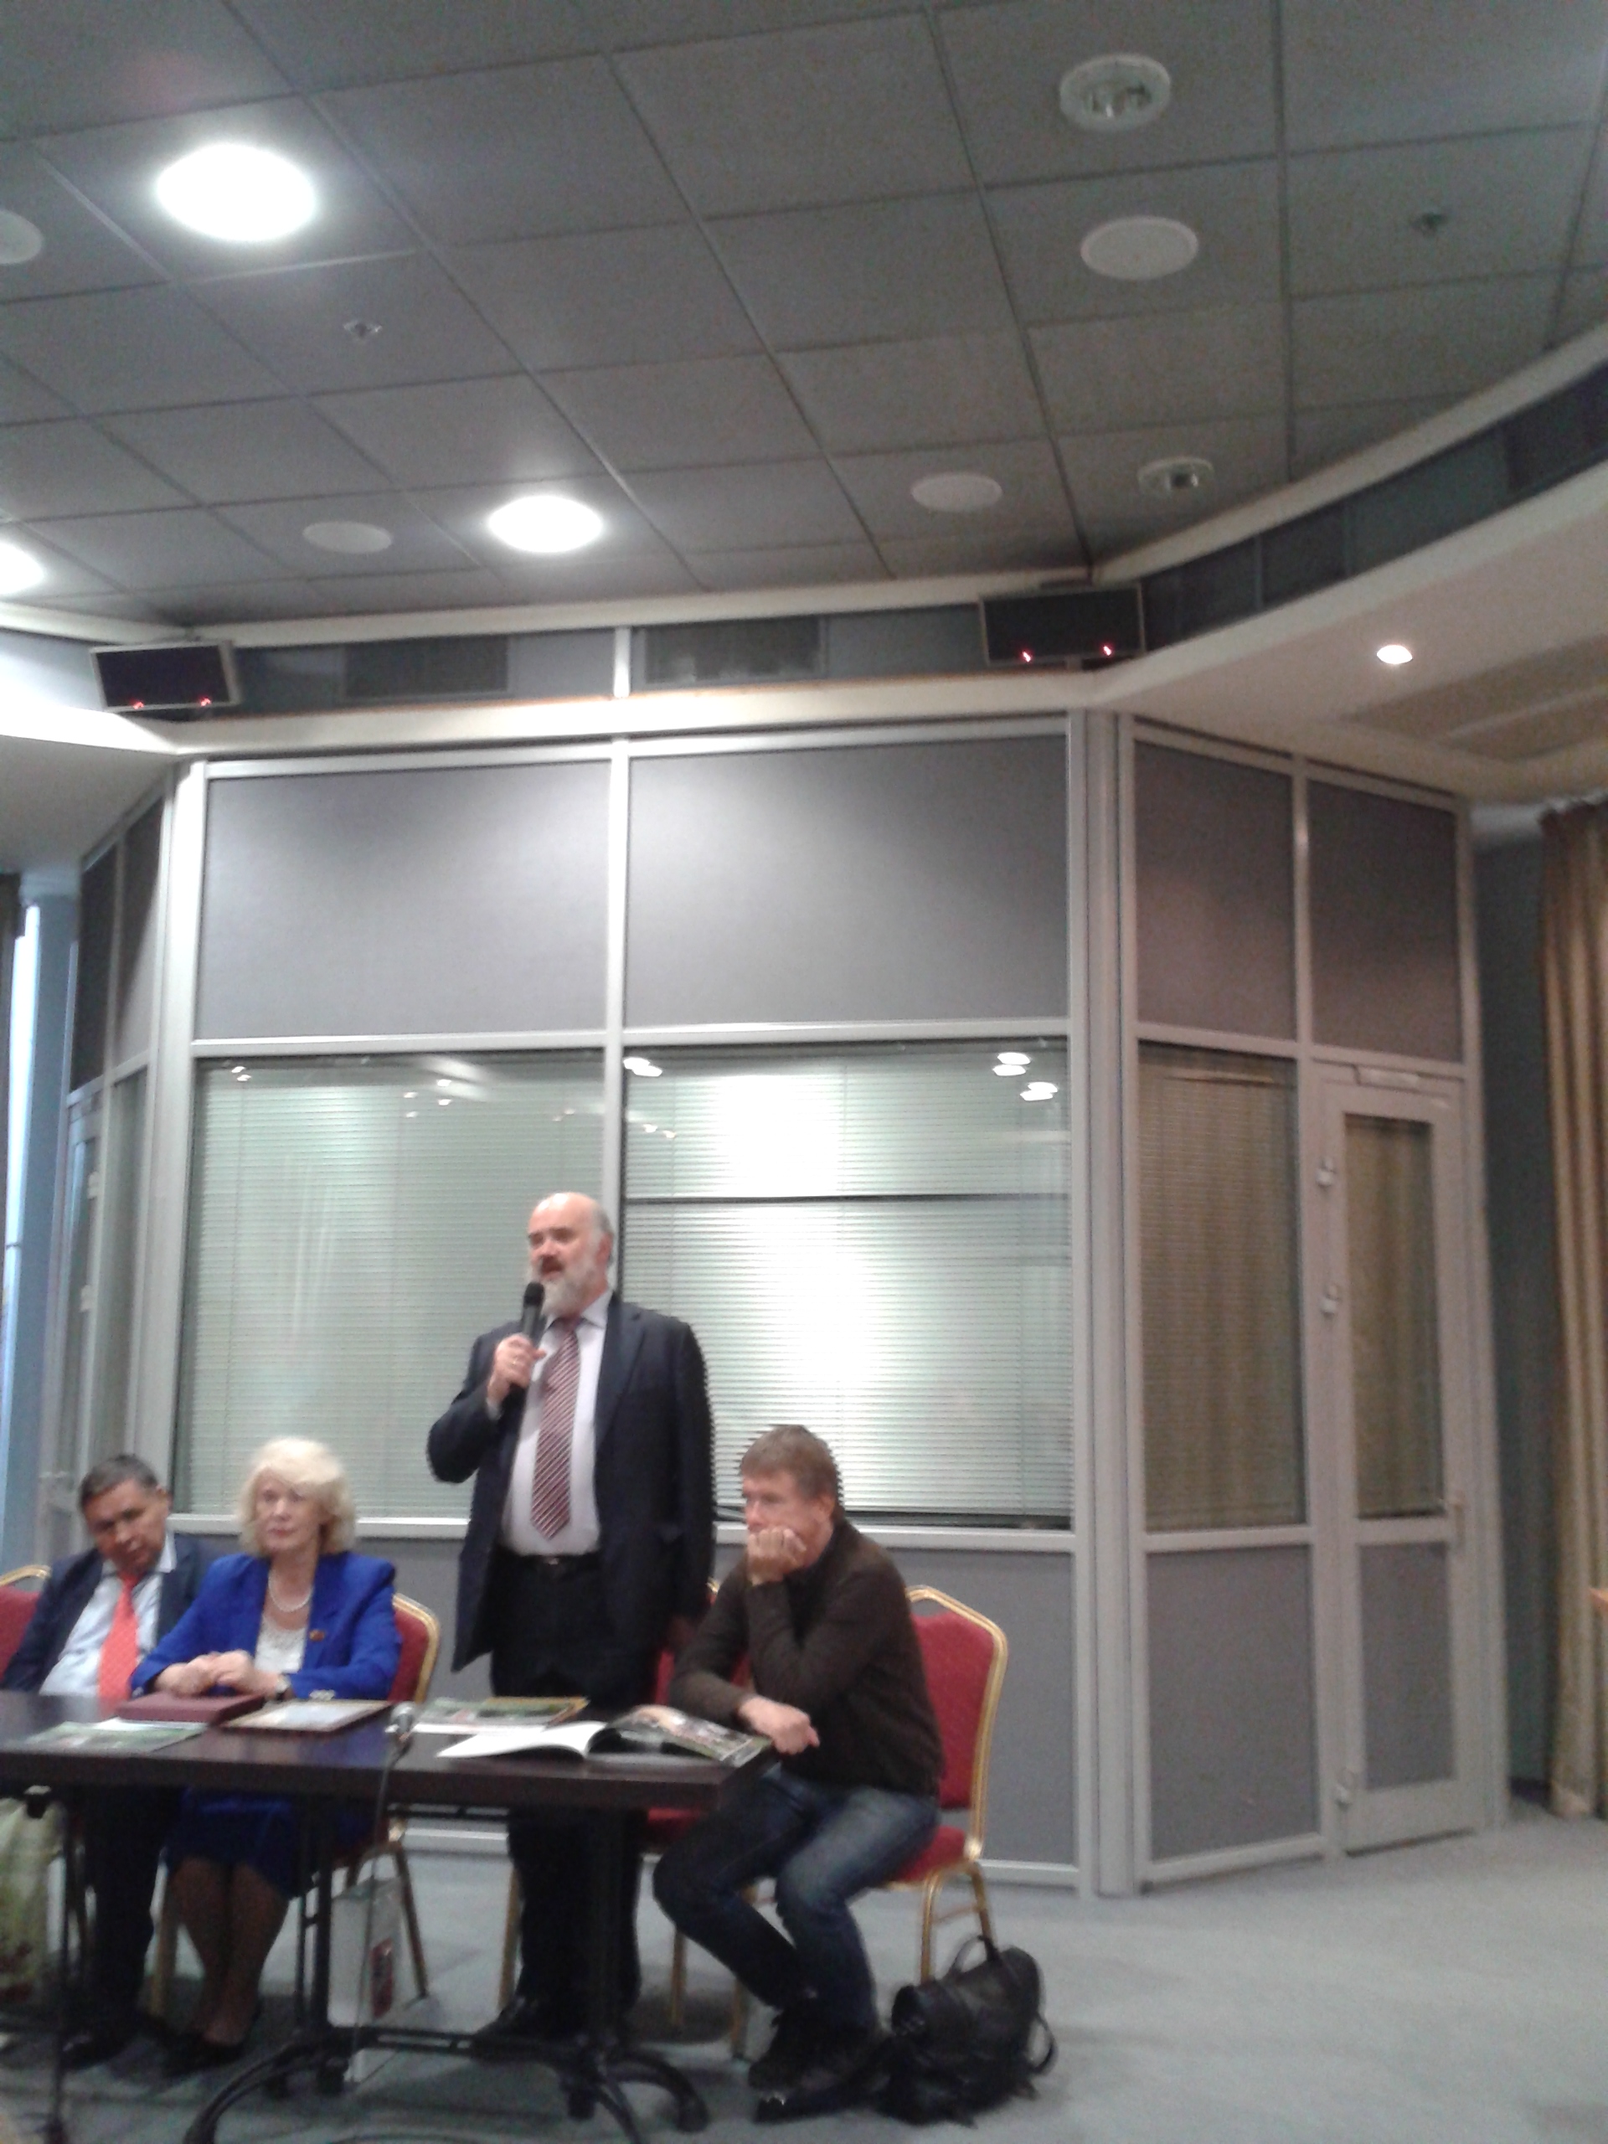

Among the attendees of the Round table there were few members of the Russian Academy of Natural Sciences: First Vice President, Chief Academic Secretary Lida Ivanitskaya and a member of the RANS Presidium, Chairman of the Interdisciplinary Ecology and Economics Systemic Studies Section, Anton Antonov.
Before the discussion, the participants attended the exhibition of the artworks by the full member of the Academy of Arts of the Russian Federation, People's Artist of Russia S.N. Andriaka and his students. Some of the exhibited works are presented below.

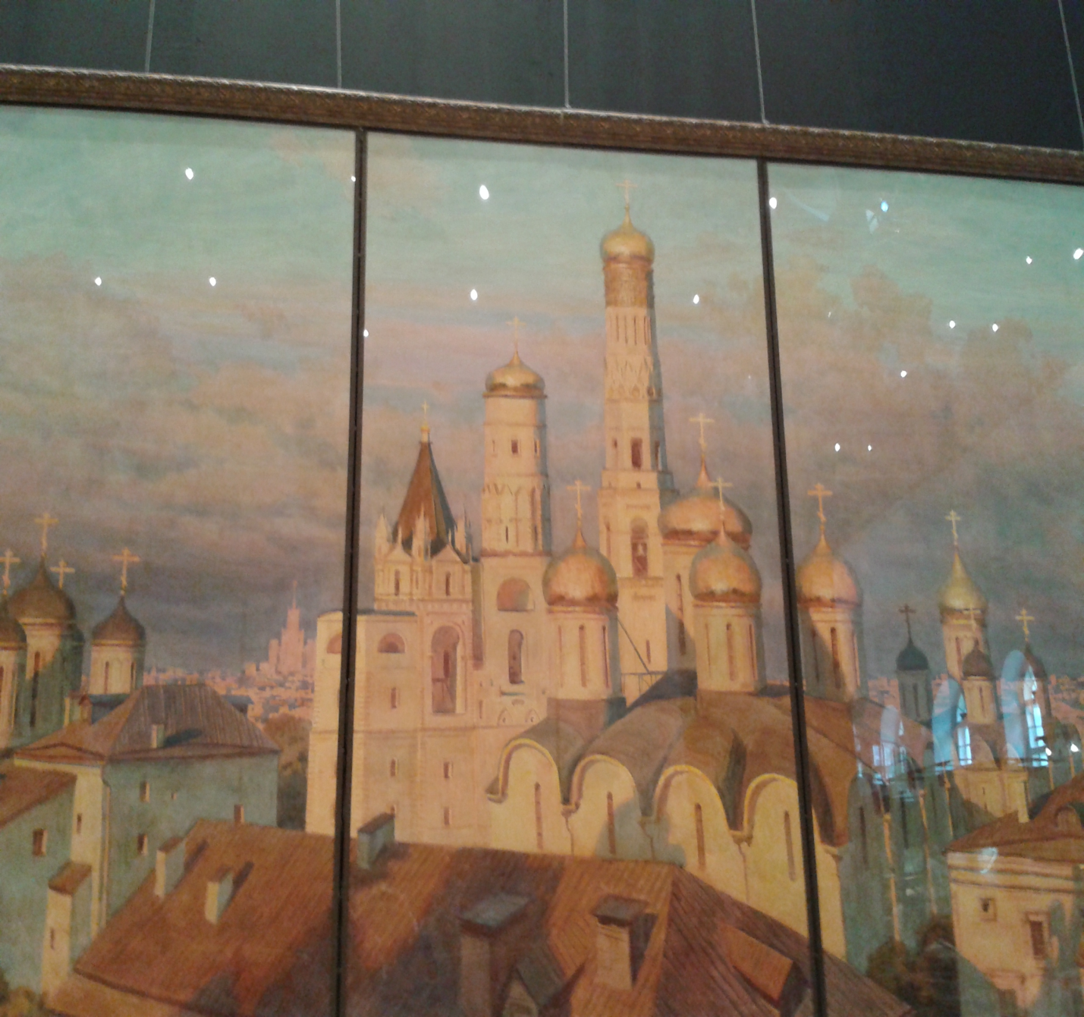

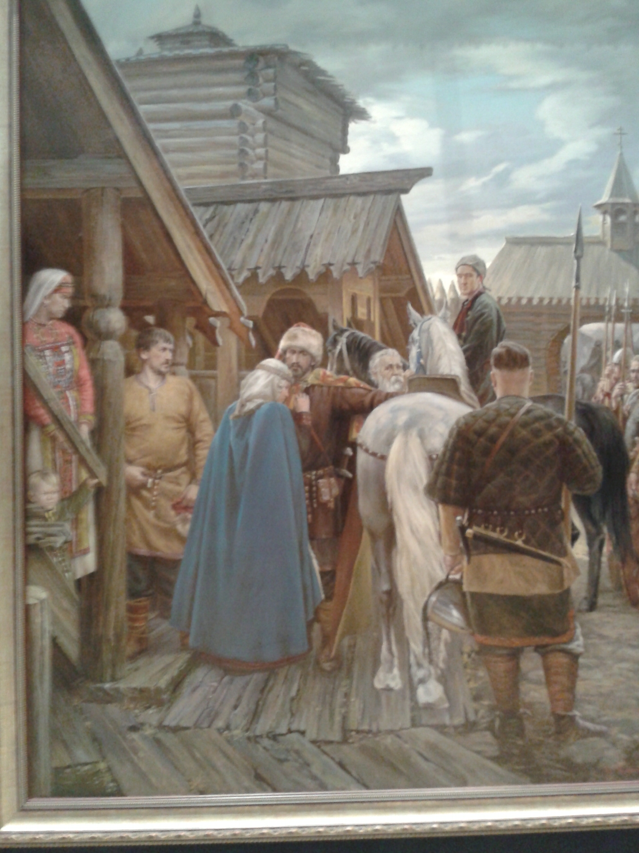

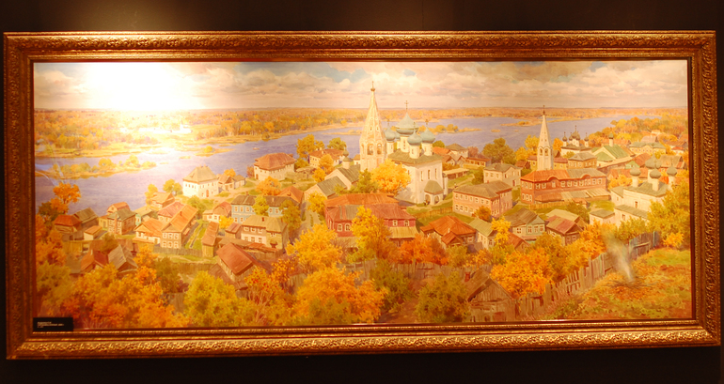

Then the participants held discussions on the problems of ecology and art.
In her talk, Z.M. Zotova paid attention to the great work that is being carried out in Moscow in terms of reconstruction and improvement of its squares, streets and parks. She also pointed out the activities of S.N. Andriaka and his students, taking much effort to show the beautiful and picturesque places of the city through their artworks.
S.N. Andriaki spoke about the role of artists in sharing the beauty of the surrounding world through their artworks, the ability to see the unusual and amazing and create images forming a new view of the environment.
L.V. Ivanitskaya devoted her message to the role of public organizations in solving environmental problems. She noted the importance of holding competitions that raise the environmental awareness and inform the public about the best achievements in this field. Ivanitskaya spoke about the activities of the Russian Academy of Natural Sciences on organization of competitions and noted that in 2017, the RANS had announced a competition for the International Environmental Award "EcoWorld" prize.
A.V. Antonov drew the attention of the round table participants to the need for cooperation between public, environmental and scientific organizations to assess the environmental situation at the district and city levels. He also pointed out the artists' creative role of conserving the truly ecologically clean and beautiful places of the city in the artworks.
N.I. Nikolaeva spoke about the work that had been done in preparation and launch of the ART Project "In the footsteps of the Red Book". To date, more than 100 artists are planning to take part in this project, and in agreement with the RANS authorities, it will be held under the framework of the "EcoWorld" International Environmental Award.

